APA STYLE

EXAMPLES OF QUOTATION
Book
Kotler, P., Keller, K. L., & Chernev, A. (2022). Marketing management. Pearson Education.
Book chapter – here delete the word "essay", which the system generates automatically
Kotler, P., & Keller, K. L. (2016). Defining Marketing for the New Realities. In Marketing management. essay, Pearson Education.

Paper (article)
Lazell, J. (2016). Consumer food waste behaviour in universities: Sharing as a means of prevention. Journal of Consumer Behaviour, 15(5), 430–439. https://doi.org/10.1002/cb.1581

Paper in conference proceedings – by title it searches only as an article in a journal, in the case of a conference it does not search for articles, but the names of conferences
Abíková, J. (2019). Motivation and job satisfaction of humanitarian logisticians. International Days of Statistics and Economics 2019. https://doi.org/10.18267/pr.2019.los.186.1

Web
KPMG International. KPMG. (n.d.). Retrieved November 19, 2021, from https://home.kpmg/cz/cs/home.html.

How to create citation
https://www.citationmachine.net/index2.php?reqstyleid=2&newstyle=2&stylebox=2
select an option „Create citation“

then you choose what you want to quote - a book, paper in a journal, etc.
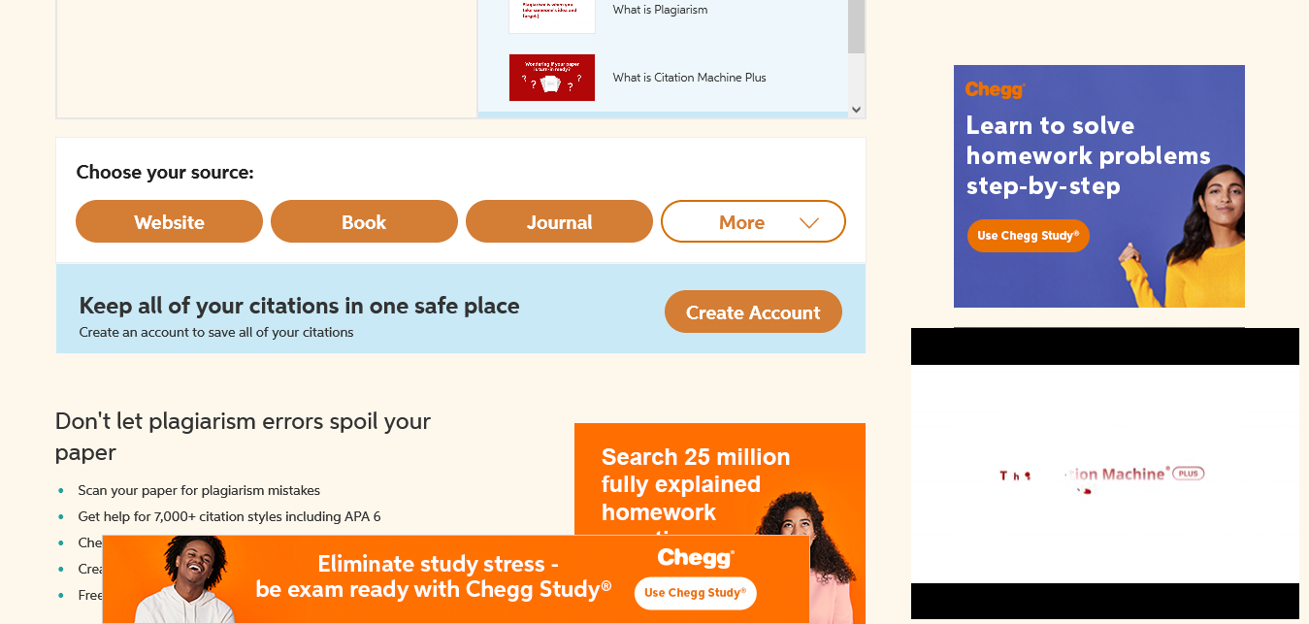
do okénka zadáte název, vyhledáte svého autora a kliknete na Cite
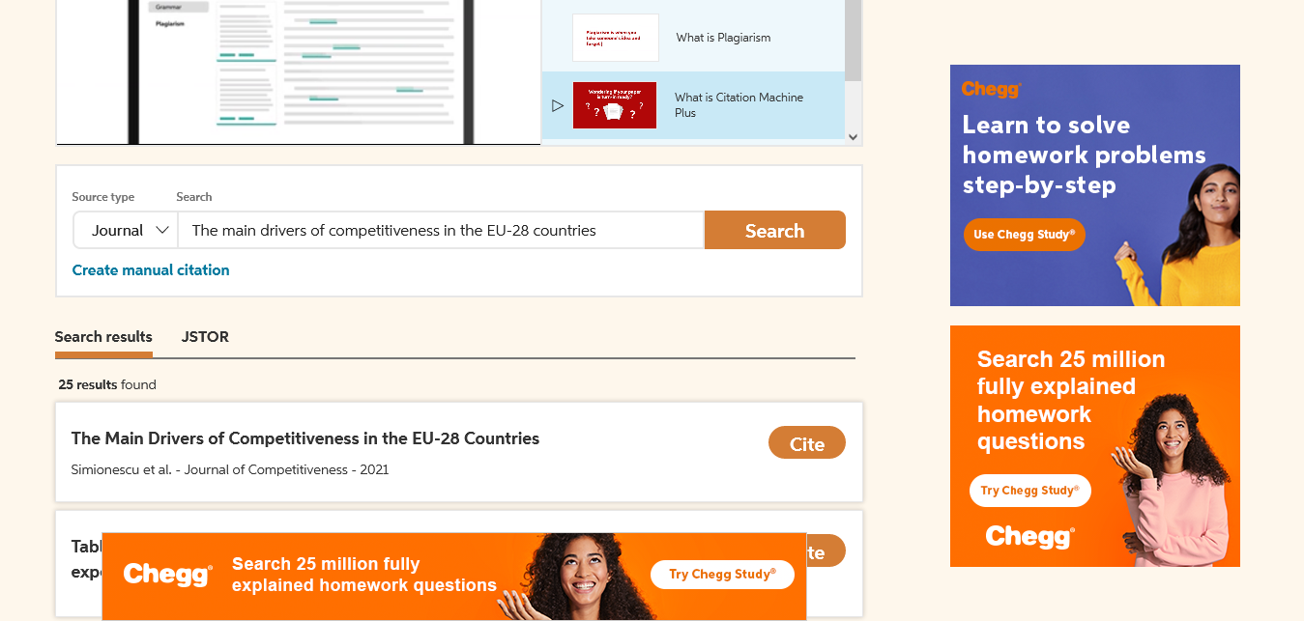

Then just click on „continue“
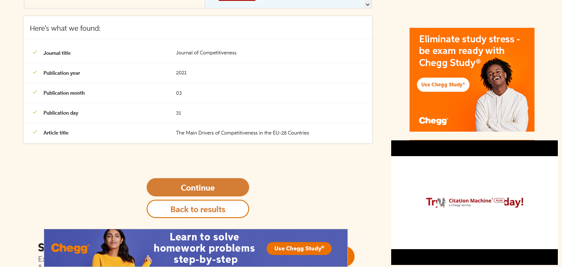

A complete citation
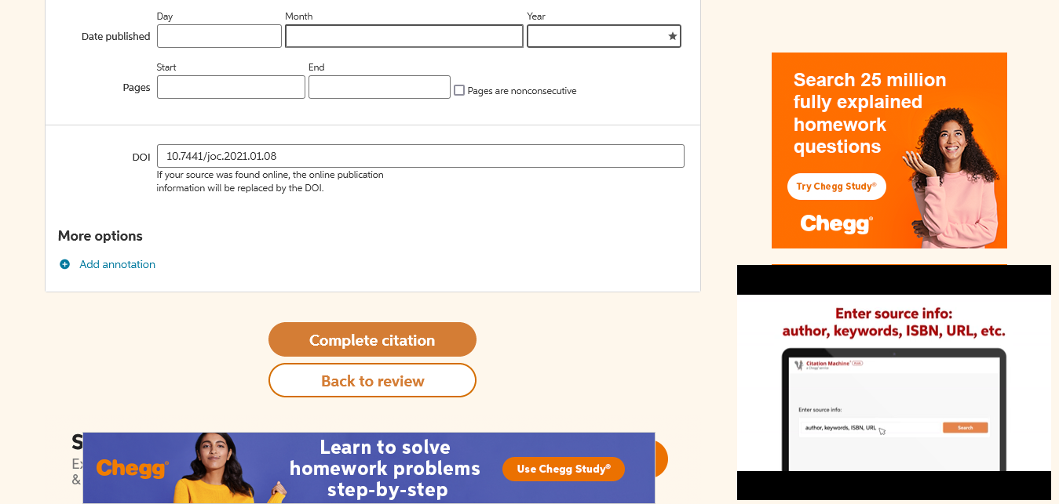
If you miss an item, you can complete it.
In the last step, you copy the citation